
The California Student Sustainability Coalition and Fossil Free UC jointly created this white paper to discuss the role of sustainable asset reallocation in addressing the climate crisis and the financial feasibility of such reallocation. There are three steps which will be discussed in sustainable asset reallocation: stopping all new investments in the top 200 fossil fuel companies, dropping pre-existing holdings in these companies within the next five years, and rolling out new reinvestment strategies. This white paper is a precursor to a report currently being developed and is scheduled to be circulated at the end of August 2013.

Introduction

The Authors:
Katie Hoffman: B.S. in Environmental Science & Policy Management from UC Berkeley, 2013; Campaign Director, California Student Sustainability Coalition
Emily Williams: B.S. in Environmental Studies from UCSB, 2013; Campaign Director, California Student Sustainability Coalition
Quentin Gee: PhD Candidate in Philosophy from UCSB ; Chair of Board of Directors, California Student Sustainability Coalition
Sections
- The Science and Social Impact of Climate Change
II. The Economic Impact of Fossil Fuels
III. Why Sustainable Asset Reallocation?
IV. The Negative Financial Impact of Fossil Fuel Investments
V. The Positive Financial Impact of Asset Reallocation
VI. Reinvestment Strategies
VII. Responses to Common Objections
VIII. Conclusion
“Invest. Divest. Remind folks there’s no contradiction between a sound environmental and strong economic growth”

-President Obama’s Remarks on Climate, June 25, 2013.
White Paper:
Sustainable Asset Reallocation: Moving UC Toward a Fossil Free Portfolio
July 2013


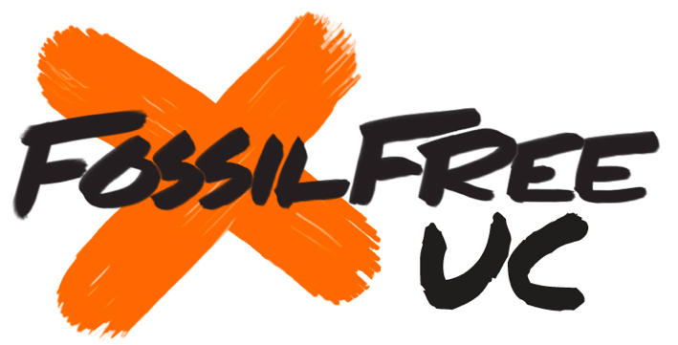
To request an electronic copy of this white paper please contact obruck@berkeley.edu
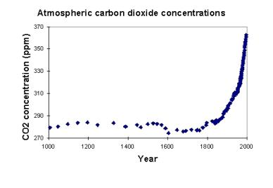

The Science and Social Impact of Climate Change
Since March of 1985, each month has been warmer than the historical global average, with 12 of the hottest years on record occurring within the last 15 years. According to the Intergovernmental Panel on Climate Change, it is scientifically unequivocal that the scientific the extraction and use of fossil fuels is the number one cause of climate change (1). In 2012, after decades of debate surrounding the causes and necessary steps that must be taken to mitigate climate change, 141 countries representing nearly 90 percent of global Green House Gas (GHG) emissions agreed that warming above 2 degrees centigrade must be avoided (2). Yet despite such an accord, the concentration of carbon dioxide (CO2) in the atmosphere has reached 400 parts per million, 50 parts per million (ppm) higher than is shown to support a maximum of 2 degrees warming (Figure 1). According to the US Environmental Protection agency “Earth's average temperature has risen by 1.4°F (0.8°C) over the past century, and is projected to rise another 2 to 11.5°F (1.1 to 6.4°) over the next hundred years” (4). Such a rise in temperature would far surpass the level of warming even the most conservative scientists have deemed as safe to continue to support life as we know it.
The global effects of warming are severe, and the costs are already socially, environmentally and economically high. According to a recent study by European NGO, Climate Vulnerable Forum, global warming contributes to the deaths of almost half a million people a year and costs the global community $1.2 trillion dollars annually. With current emissions, it is generally the countries of lower socio-economic standing who are most affected. However, with continued rates of emissions, all communities may be affected by climate change which can in turn lead to civil unrest (5). The effects of too much atmospheric CO2 are innumerable: ocean acidification, melting arctic ice, melting permafrost, water shortages and droughts, floods, loss of biodiversity, coastline erosion, increases in the occurrence and intensity of heat waves, and the disappearance of entire countries, such as the Maldives, due to sea level rise (6).
With scientific consensus that warming must stop before global temperatures rise 2 degree C, and with the amount of carbon the fossil fuel industry burns, it is no longer a question that action must be taken with regards to emissions if humanity is to have a 50 percent chance of stabilizing the earth’s climate at a global temperature in which human life evolved (7).

Figure 1 Atmospheric carbon dioxide concentration levels have steadily increased since the industrial revolution, and are much higher than the historical record has seen for the past 1000 years (3).
Sections
- The Science and Social Impact of Climate Change
II. The Economic Impact of Fossil Fuels and Climate Change
III. Why Sustainable Asset Reallocation?
IV. The Negative Financial Impact of Fossil Fuel Investments
V. The Positive Financial Impact of Asset Reallocation
VI. Reinvestment Strategies
VII. Responses to Common Objections
VIII. Conclusion

II. The Economic Impact of Fossil Fuels and Climate Change
Economic Impacts of Fossil Fuels
Extraction of the major fossil fuels— natural gas, coal, and petroleum—generated approximately $340 billion in revenues in 2011. However, some of this extraction does not lead directly to energy use (e.g., plastics production), and these energy sources are vital primary inputs for other drivers of the US economy (8). However, oil imports alone cost the US economy approximately $330 billion per year (9). The utilization of fossil fuels plays a key role in the global economy, yet fossil fuels’ main asset is the energy they provide. However, that energy can be supplied by other sources that have a dramatically lower climate impact by switching to a low-carbon economy, which would in turn help to reduce the US trade deficit.
Despite the current importance of fossil fuels to the national and global economy, there are many long-term risks associated with their continued use. For instance, according to one of the leading reinsurance companies, Munich Re, natural disasters and severe weather conditions, many of which can be linked to climate change, resulted in $160 billion in losses for 2012. The head of Munich Re’s Geo Risk Research says that such disasters exemplify “the type of events we can expect to contend with more often in the future” in a world of climatic change (10). In addition, the Climate Vulnerable Forum, a partnership of countries expected to be most severely affected by climate change, estimates $1.2 trillion in annual economic losses in the most vulnerable countries, primarily due to agricultural impacts, labor productivity losses, and ecosystem services impacts (11).
Other impacts of fossil fuels are the toxic, non-climate-related emissions, including noxious forms of particulate matter (PM) and sulfur dioxide (SO₂), as well as direct contamination of groundwater and land. Harvard University’s Center for Health and the Global Environment estimates such impacts cost $295 billion per year due to coal extraction and use in the United States (12). The added costs associated with petroleum only exacerbate such negative impacts. For instance, a recent study at California State University Fullerton shows that Southern California alone suffers $28 billion per year in economic losses due to air pollution in the area, the primary result of vehicle emissions (13).
Though it is dependant on carbon-intensive energy sources today, the global economy does not require the burning of fossil fuels in the long run to sustain vibrant and sustainable economic activity. Indeed, when considering external costs, alternative sources of energy become more economically preferable. A phase out of fossil fuels over the next few decades would have a tremendous positive effect on human health and ecosystem services, as well as slow climate change. As governments across the world begin to recognize externalities as part of the cost of these fuels, and as substitute technologies become more readily available and easily affordable, shifts in energy sources are more likely to occur.

Sections
- The Science and Social Impact of Climate Change
II. The Economic Impact of Fossil Fuels and Climate Change
III. Why Sustainable Asset Reallocation?
IV. The Negative Financial Impact of Fossil Fuel Investments
V. The Positive Financial Impact of Asset Reallocation
VI. Reinvestment Strategies
VII. Responses to Common Objections
VIII. Conclusion
Climate Change Effects
Recent events in the United States that have been scientifically linked with climate change include the intensification and more frequent occurrence of hurricanes, heat waves, floods, droughts, and wildfires (14). The current global effects of climate change include at least 150,000 annual deaths according to the World Health Organization. This occurs in the form of temperature related illnesses, extreme weather related effects, water and food-borne diseases, vector and rodent-borne diseases, food and water shortages, and effects of population displacement (15). A more recent estimate from the Climate Vulnerability Forum places the toll at 400,000 people per year (16).

Sections
- The Science and Social Impact of Climate Change
II. The Economic Impact of Fossil Fuels and Climate Change
III. Why Sustainable Asset Reallocation?
IV. The Negative Financial Impact of Fossil Fuel Investments
V. The Positive Financial Impact of Asset Reallocation
VI. Reinvestment Strategies
VII. Responses to Common Objections
VIII. Conclusion
Despite the scientific consensus on anthropogenic climate change, the majority of the world’s governments have failed to take the necessary steps to address the crisis. Stalled progress on comprehensive climate legislation can be attributed in large part to the undue political influence held by the fossil fuel industry over political and economic decision making (17). While the U.S. is now the second largest emitter of CO2, with China taking the lead as of 2012, U.S. emissions have historically contributed to roughly 30 percent of all global GHG concentrations to date (Figure 1). Despite knowledge of what needs to be done to mitigate the climate crisis, fossil fuel companies spend a combined $400,000 a day lobbying the U.S. congress to halt climate legislation, delay government support for renewable energy research and development, and maintain billions of dollars in fossil fuel subsidies (18). Inaction at the federal level has led to city, state, and institutional efforts to reduce carbon emissions and push for federal climate policy, and one of several strategies being utilized is that of removing asset holdings from fossil fuel companies.
Hundreds of cities, universities, faith-based communities and financial institutions across the U.S. and the globe are leveraging fossil fuel divestment in order to fulfill fiduciary responsibilities, apply pressure on fossil fuel companies to shift their business models, and raise public awareness of climate change (19). In ridding portfolios of fossil fuel stocks, institutions send a message both to investors and to the wider public stating that companies and their business models are a poor financial investment and a social and environmental threat. As increasing numbers of institutions drop their stocks, market uncertainty will grow alongside public awareness and demand for cleaner energy alternatives. In addition to pending climate legislation, these pressures will force fossil fuel companies to either shift their business models to minimal carbon energy production, or go out of business (20). Since we cannot wait for climate legislation, divestment serves as an effective mechanism to expedite this process and help force climate change onto the national political agenda. Moreover, in the case of the UC, it provides an opportunity to align the institution’s investment practices with its existing climate change policies and commitments as well as its stated sustainability values and goals.

III. Why Sustainable Asset Reallocation?

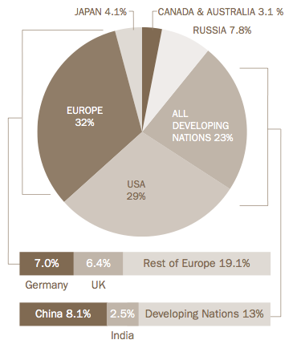
Figure 1: Proportions of Cumulative Global GHG Emissions, 1750-2007.

Source: “Taking Responsibility: The US Must Lead the World in Reducing Global Warming Pollution.” National Environmental Trust, Washington DC. 2007. Page 1. Full report available at: www.pewtrusts.org

Sections
- The Science and Social Impact of Climate Change
II. The Economic Impact of Fossil Fuels and Climate Change
III. Why Sustainable Asset Reallocation?
IV. The Negative Financial Impact of Fossil Fuel Investments
V. The Positive Financial Impact of Asset Reallocation
VI. Reinvestment Strategies
VII. Responses to Common Objections
VIII. Conclusion
As outlined in section 2, scientists agree that to have a 50 percent chance of maintaining a climate in which life as we know it evolved, temperatures must not rise above 2 degrees C. In order to reach this goal, minimal emissions can be released after 2050 (21).
In 2012, the Carbon Tracker Institute, a non-partisan think tank based in London, released a report illustrating that the amount of carbon the 200 leading fossil fuel companies hold in their proven reserves is recorded at five times the limit scientists have determined is safe to burn in order to prevent 2 degrees of warming. That is, in order to avoid the 2 degrees mark and avert runaway climate change, human beings can only burn 565 gigatons of carbon, while current reserves are estimated at 2,860 gigatons (figure 2).
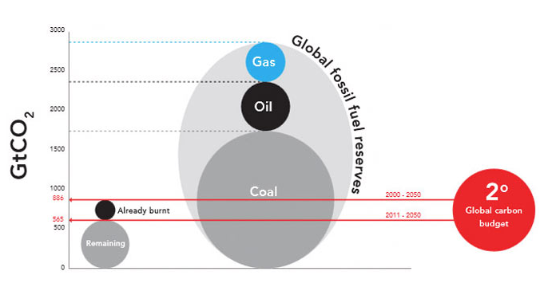
Figure 2: Comparison of the global 2°C carbon budget with fossil fuel reserves CO2 emissions potential. In “Unburnable Carbon 2012” global carbon reserves are estimated at 2,795 gigatons, while in “Unburnable Carbon 2013” they are estimated at 2,860 gigatons. Photo credit: Carbon Tracker Initiative. Unburnable Carbon. 2012. Pg. 6.

In the Carbon Tracker Initiative’s new report, “Unburnable Carbon 2013: Wasted Capital and Stranded Assets,” they estimate that if 565 gigatons of carbon burned is the acknowledged safe limit, that “65-80% of listed companies’ current reserves cannot be burned unmitigated”(22). The listed fossil fuel companies do not intend to meet this mark, but rather continue extracting and burning reserves as usual, as made apparent by their most recent annual capital expenditure figures. In 2012 alone, oil, gas, and coal companies spent $674 billion exploring and developing new reserves (23). Holding investments in companies that actively trade commodities that are locked into the ground by law drives the stock values above their true valuation. This phenomenon is known as the “carbon bubble” (Figure 3).
The International Energy Agency, in its special report entitled Redrawing the Energy Climate Map released June 10, 2013, comes to a similar conclusion as the Carbon Tracker Initiative. The report details that upstream oil and gas assets could in fact be stranded if invested in developments to take place after 2035 (24). It says that many planned oil and gas fields to be explored after 2035 will be blocked by legislation, billions of dollars spent on exploration as wasted capital. In its 2012 World Outlook, the IEA found that in order to reach the 2 degree C mark, only one third of all fossil fuel reserves can be burned (25).

IV. The Negative Financial Impact of Fossil Fuel Investments
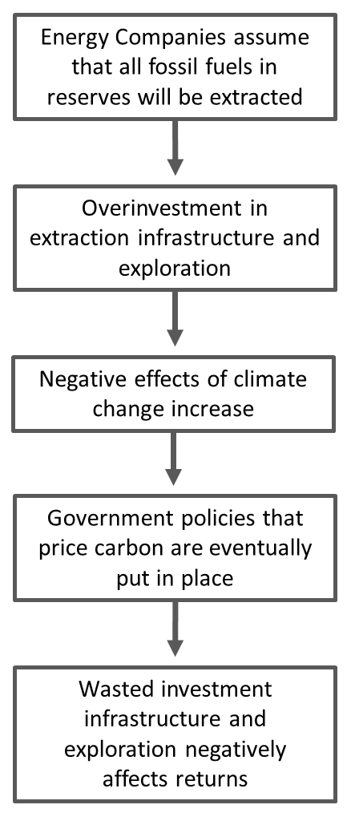
Figure 3. The Structure of the Carbon Bubble

Sections
- The Science and Social Impact of Climate Change
II. The Economic Impact of Fossil Fuels and Climate Change
III. Why Sustainable Asset Reallocation?
IV. The Negative Financial Impact of Fossil Fuel Investments
V. The Positive Financial Impact of Asset Reallocation
VI. Reinvestment Strategies
VII. Responses to Common Objections
VIII. Conclusion

IV. The Negative Financial Impact of Fossil Fuel Investments
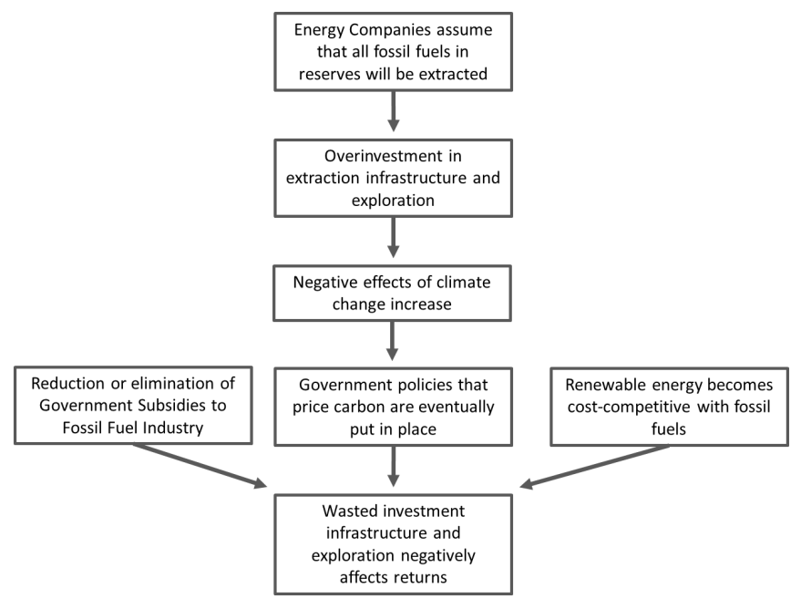
According to recent research by HSBC Global building off the IEA’s findings, if any policy actions are taken regarding climate change the returns on fossil fuel investments may decrease while risks increase, leading up to a 40-60% loss of current market capitalization (26). To date, the carbon bubble has been studied by multiple organizations—HSBC, IEA, the Carbon Tracker Initiative, Deutsche Bank, Citi Group, and the Canadian Centre for Policy Alternatives—which outline the risk of remaining invested in such companies. Many institutions warn against trading carbon futures because they are not likely to remain highly profitable over time given the tendency of markets to price such assets far beyond their value to society and the real economy.
In 2009, the UN Environmental Program Finance Initiative (UNEPFI) released a study, which argued it is the legal responsibility of fiduciaries to integrate environmental, social and governance criteria into investment decisions. When considering various climate change and legislation scenarios, it becomes evident that there is substantial financial risk in holding investments in an industry whose business model is based almost entirely upon assets that can be rendered unrecoverable. As figure 4 illustrate, remaining invested in such a bubble is highly risky, and is no longer the most prudent decision for institutional investors such as the UC given the nature of climate risk and the need to adjust investment practices accordingly (27). The Carbon Tracker Initiative advises the following to investors: “Reduce holdings in carbon-intensive companies and use re-balanced, carbon-adjusted indices as performance benchmarks; redistribute funds to alternative opportunities aligned with climate stability” (28).

Figure 4 Factors that render fossil fuel investments unprofitable and risky.

The previous section outlined the risks associated with the carbon bubble. This section examines the financial impact if sustainable asset reallocation takes place. Sustainable asset reallocation in this case involves moving investments away from the top 200 fossil fuel companies to fossil-free portfolios. While studies indicate that remaining invested in the fossil fuel industry creates financial risk, sustainable asset reallocation would satisfy the fiduciary responsibility of the university, as there is nothing to indicate a loss in revenues and increase in risk.
Several studies indicate that were sustainable asset reallocation to occur, endowments would see either no change in returns or an increase in returns. A study from financial consultant agency, the Aperio Group, found that with divestment comes minimal risk and no appreciable effect on returns when comparing the Russell 3000 index fund and the same fund excluding the top 200 fossil fuel companies (29). Another study by the Associated Press, which used the S&P 500 index, shows that if divestment occurred ten years ago, a $1 billion endowment at the time would have yielded $119 million more than the same endowment with no divestment (30). Yet another study, released by Impax Asset Management, used the MSCI World Index fund in and created four different portfolios: the “Fossil Free Portfolio,” the “Fossil Free Plus Alternative Energy (Passive) Portfolio,” the “Fossil Free Plus Alternative Energy (Active) Portfolio,” and the “Fossil Free Plus Environmental Opportunities (Active) Portfolio.” The study looked at a five to seven year period, and found that having implemented any one of the aforementioned portfolios would have increased returns with minimum tracking error. The returns on the annualized portfolios were 1.8% for the normal MSCI World fund, and 2.3%, 1.9%, 2.2%, and 2.3% respectively for the four fossil free portfolios. The tracking errors on the four fossil free portfolios were 1.6%, 1.8%, 2.0%, and 1.6% respectively (31).
Furthermore, increased divestment from fossil fuels, when combined with predicted growth in demand for low-carbon energy, products, and services, will lead to rapid growth in the market for profitable carbon-free investment products. Bloomberg New Energy predicts that annual investment across all renewable energy generation will increase three-fold over the next 15 years to $630 billion (32). Additionally, predicted correlations between carbon legislation and the devaluation of fossil fuel stocks are already manifesting as is the case with coal. As climate legislation continues to render fossil fuel stocks increasingly worthless and more institutions divest holdings, available options for sustainable asset reallocation will rise exponentially.

V. The Positive Financial Impact of Asset Reallocation
Sections
- The Science and Social Impact of Climate Change
II. The Economic Impact of Fossil Fuels and Climate Change
III. Why Sustainable Asset Reallocation?
IV. The Negative Financial Impact of Fossil Fuel Investments
V. The Positive Financial Impact of Asset Reallocation
VI. Reinvestment Strategies
VII. Responses to Common Objections
VIII. Conclusion

Governments are beginning to move forward on climate change initiatives. For instance, Ireland, Australia, and British Columbia have implemented carbon taxes, and rapidly developing nations such as China are in the process of developing the appropriate market based solutions to mitigate emissions (33). Recent regulatory proposals from the Obama administration develop strategic plans to place additional regulations on the industry, which will further reduce the profitability of fossil fuel investments and increase returns on alternative portfolios (34).
Considering the studies above, if the UC remains invested in the fossil fuel industry there is an above average probability that the institution will incur losses. Furthermore, if national policy fails to regulate carbon emissions, the endowment is likely to see no change in revenues and risk. If governments begin to regulate emissions, a carbon-free portfolio will produce higher returns as compared to its carbon counterpart.

VI. Reinvestment Strategies
The University of California is committed to increasing energy efficiency and moving towards bold goals of zero waste by 2020 (35). Currently however, the Regents do not hold a policy that utilizes the endowment or investment portfolio as a means of achieving environmental and social governance (ESG) and system-wide energy efficiency goals. That is why we suggest UC leadership consider the pathways to fossil-free investing most recently outlined in a report by the Tellus Institute (figure 5).

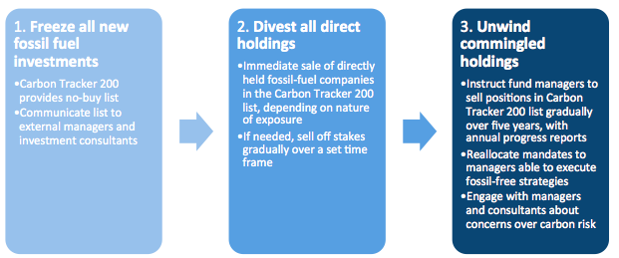
Figure 5: Divestment Pathway to a Fossil-Free Portfolio in 5 years. Joshua Humphreys, “Pathways to Fossil-Free Investing.” Tellus Institute, 2013. Pg 6.

Given the mounting evidence of a carbon bubble and the need to incorporate ESG into the UC system’s investment practices, this section will provide a general overview of some alternative pathways to move UC toward a fossil free and climate risk-adjusted portfolio. As figure 5 below illustrates, the opportunities for asset reallocation across classes are many, and our team intends to provide a detailed analysis of such opportunities for the UC in our final report. As an introduction to the vast opportunities for reinvestment moving forward, this section will briefly introduce two examples of promising vehicles for asset reallocation in the Fixed Income and Cash & Equivalents classes respectively: Green Revolving Funds (GRFs) and Community Development Financial Institutions (CDFIs).

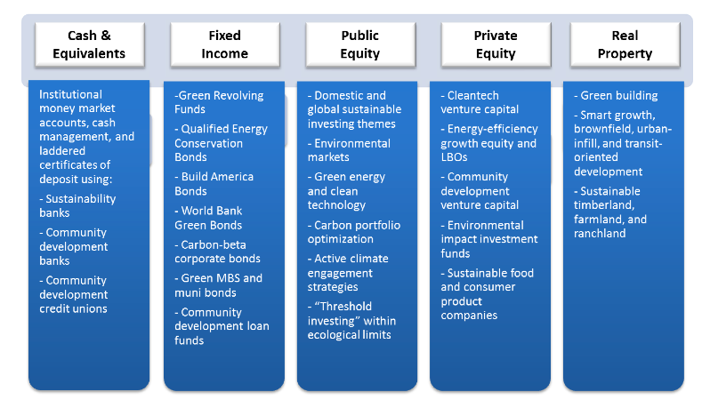
Figure 6: Sustainable Fossil-Free Investing Opportunities across Asset Classes.“Pathways to Fossil-Free Investing.” Tellus Institute, 2013. Pg 14.

Sections
- The Science and Social Impact of Climate Change
II. The Economic Impact of Fossil Fuels and Climate Change
III. Why Sustainable Asset Reallocation?
IV. The Negative Financial Impact of Fossil Fuel Investments
V. The Positive Financial Impact of Asset Reallocation
VI. Reinvestment Strategies
VII. Responses to Common Objections
VIII. Conclusion
Sections
- The Science and Social Impact of Climate Change
II. The Economic Impact of Fossil Fuels and Climate Change
III. Why Sustainable Asset Reallocation?
IV. The Negative Financial Impact of Fossil Fuel Investments
V. The Positive Financial Impact of Asset Reallocation
VI. Reinvestment Strategies
VII. Responses to Common Objections
VIII. Conclusion

VI. Reinvestment Strategies
Green Revolving Funds: One cost-effective and carbon-reducing method of furthering ESG goals through investment policies with a successful track record is the implementation of a GRF (36). In general, GRFs invest in energy efficiency projects, resulting in a reduction of operating expenses and GHG emissions. The cost savings boost the bottom line and replenish the fund for investment in the next round of energy efficient or otherwise sustainable retrofits, thus establishing a renewable funding cycle. To date, 76 colleges and universities in the U.S. and Canada have implemented different GRF models: the Efficiency fund, the Innovation and Engagement fund, and the Hybrid Fund. According to a survey conducted by the Sustainable Endowments Institute, there is a pattern of reliable returns on investment (ROI) and short repayment periods, making this option a lucrative area of exploration for UC. For example, of the eighteen schools that reported ROI figures, there was a ROI range from 20 percent, at both Georgia Tech and University of North Carolina at Chapel Hill, to 57 percent at Boston University (37). Established funds report a median annual ROI of 28 percent (38). This data suggests that GRFs can significantly outperform average endowment investment returns, while maintaining robust and sustainable returns over longer periods of time.

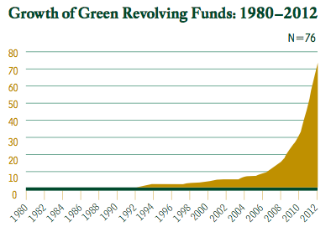
Graph Credit to: SEI, “Greening the Bottom Line,” 2012.

Community Development Financial Institutions:
Another opportunity for mission aligned reinvestment is allocating a percentage of cash assets towards FDIC backed CDFIs that generate localized economic development by providing low interest loans to families, individuals and businesses in the areas they operate. There are six types of CDFIs according to the CDFI coalition, and our forthcoming report will analyze the three we believe are most relevant to the UC’s interests (39). Despite varying methods for measuring the overall return on CDFI investments over time, experts in the socially responsible investment field argue that CDFIs have historically and consistently generated a “triple bottom line” for investors—environmental, social and economic returns. Furthermore, a recent study produced by the Carsey Institute indicates that “CDFIs have expanded their assets and their loan portfolios since the market peak in 2005, as the economic crisis has made it harder to access traditional credit markets”(40). Given the room for growth with CDFIs, and the UC’s purpose to serve the public good, it is logical to consider reallocation toward CDFIs across the state that will boost the economic vitality of local and regional communities, therein generating much needed sustainable development for California as a whole, while providing substantial ROIs for the UC.

Types of Green Revolving Funds:

• The Efficiency Fund to provide capital for energy and/or water efficiency measures

• The Innovation and Engagement fund to seek out community engagement and project proposals, and

• The Hybrid Fund that combined both interests in efficiency projects while also supporting greater campus or community involvement.

Source: “Greening the Bottom Line,” 2012.

Figure 3, Growth of Green Revolving Funds: 1980-2013. Taken from: SEI, “Greening the Bottom Line,” P

Sections
- The Science and Social Impact of Climate Change
II. The Economic Impact of Fossil Fuels and Climate Change
III. Why Sustainable Asset Reallocation?
IV. The Negative Financial Impact of Fossil Fuel Investments
V. The Positive Financial Impact of Asset Reallocation
VI. Reinvestment Strategies
VII. Responses to Common Objections
VIII. Conclusion

VII. Responses to Common Objections
What follows are arguments that we’ve heard about divestment and our responses to them. It is important to bear in mind that none of the arguments below actually engage the moral arguments for divestment, and we have not actually encountered a rebuttal to the moral arguments, nor have we found substantive positive moral arguments to remain invested. What follows are responses to practical objections.

1. Shareholder engagement: The UC system could be more effective by more actively engaging the companies in which they are invested. Divesting means we would no longer have a say in the companies. This would mean we would have no right to, say, sponsor shareholder resolutions.
This argument would potentially be effective for companies that have less egregious practices, or for companies that were more responsive to shareholder engagement. However, the fossil fuel industry has time and again ignored shareholder resolutions that call for any large-scale improvements. For instance, the organization As You Sow has helped author numerous fossil fuel resolutions, with minimal success or change on the part of the companies. The organization also notes that divestment can bolster shareholder advocacy that remains, as companies may actually listen once large institutional investors make a bold move (41).

2. Carbon Tax: The UC system should try to offer broader solutions rather than divest. For instance, we could vigorously pursue a policy such as a carbon tax, which many economists agree is the most simple and straightforward way to manage the carbon problem within a market system.
With the current policy climate so heavily influenced by corporations, legislation that would push for a carbon tax is frozen. Although there are fewer registered lobbyists in Washington (it is currently down to 8,823; about 17 per member of the legislative branch), more and more lobbying is done behind the scenes in an unregistered way (41; 42). Divestment strips these corporations of their credibility, and legitimates the claim that these companies can no longer seen as beneficial to society, despite their best public relations efforts to the contrary. This change in attitude clears the table for a fair and unbiased discussion of the carbon tax and other policy mechanisms.

3. Fossil Fuel Companies Invest a lot in Renewables: Fossil fuel companies generally see themselves as energy companies, and have invested a great deal in renewable energy. To divest from them is to discourage them from cleaning up their energy sources.
The fossil fuel industry has generally avoided renewable energy in favor of more extraction of carbon-based energy. For instance, although the American Petroleum Institute points to $71 billion invested in energy improvements in the last decade, only $9 billion of that was actually invested in renewable energy (43). By contrast, the petroleum industry has dedicated $341 billion in developing tar sands technology during that same period (44). Furthermore, global energy investment in renewables for year 2011 alone topped $257 billion (45). These numbers show that the fossil industry is only concerned with extraction, not viable alternatives to extraction.

Sections
- The Science and Social Impact of Climate Change
II. The Economic Impact of Fossil Fuels and Climate Change
III. Why Sustainable Asset Reallocation?
IV. The Negative Financial Impact of Fossil Fuel Investments
V. The Positive Financial Impact of Asset Reallocation
VI. Reinvestment Strategies
VII. Responses to Common Objections
VIII. Conclusion
4. No Politics: It is not the UC’s role to get involved in political matters. This proposal steps over the bounds of being a research and educational institution.
Investing is in itself a political statement, especially once it is made well-known that an institution is actively and highly invested in an industry associated with large-scale political problems. Although it is not the direct intention of the investments committee to exacerbate climate change, the declarations of our own institutions of the dramatic consequences of policy inaction and complicity are taught to students time and time again in almost every department of our University. We do not want to be a “do as I say, not as I do” institution on such an important issue. Additionally, climate change is not a partisan issue, as both sides have not engaged the issue enough (hence the problem), and
solutions have been offered by minority figures in both, so divestment is much less political than one might think. What’s more, the UC has been involved in political matters, including lobbying (47). The UC has also politically engaged on Sudan, South Africa, and tobacco, regarding genocide, apartheid, and public health, respectively. Although each were important matters, climate change is clearly much more dangerous in terms of severity of its global impact and effect on human populations.

5. Divestment is too risky: There is a high amount of risk associated with pulling out from a single industry. This could affect long-term profits.
Divesting from one industry is not in itself fundamentally risky. While it is possible that long term profits could be affected, the arguments presented in favor of divestment (see arguments 3 & 4 above) show that the negative perspective is at best contentious. And given potential catastrophic events’ potential impact to spur public dialogue, failure to divest is in some ways associated with high risk itself. Public opinion on climate change, although somewhat variable (and linked to the increasing ineffectiveness of the fossil fuel industry’s public relations tactics), is transitioning to a broader agreement that something must be done.

6. Green our Campuses First: There are better, more relevant things to do on our campuses that show our commitment to mitigating climate change. For instance, we would have stronger green building standards, source our energy from clean sources, and encourage faculty, staff and students to drive less.
The UC system has a very strong policy on sustainable practices that includes things such as local organic food, green purchasing, and green building standards (48). However, at this point, improving such standards will yield diminishing returns. We certainly should look to additional opportunities in these areas, but we cannot ignore the broader implications of investment in industries actively and consciously engaged in exacerbating climate change.

VII. Responses to Common Objections

According to the UC Annual Report of Sustainability Practices for 2012, “the University’s campuses and medical centers continue to be recognized as national leaders in modeling sustainable business practices”(49). The goals and vision for continued leadership on issues related to sustainability are bold, and it is clear that the institution has pioneered efforts to reduce waste, increase energy efficiency and incorporate environmentally preferred principles into purchasing practices and overall institutional operations. In the pursuit of a more environmentally, socially and economically sustainable California for current and future generations, it is imperative that UC leadership work with all interested parties to develop investment policies aligned with the institution’s mission. Remaining invested in the fossil fuel industry, and neglecting to incorporate ESG policies for all institutional investments, will inhibit the UC from remaining a national and international leader in sustainable practices and public education. Given the mounting global climate crisis, and growing recognition that fossil fuels must be kept underground to avoid certain climate catastrophe, the UC is uniquely positioned to develop comprehensive policies that are both aligned with the social and environmental goals of the institution, and circumvent undue financial risks presented by the carbon bubble. Our team looks forward to providing more detail on the specific ways UC leadership can move forward on developing a fossil-free portfolio, and we appreciate the opportunity to work with all interested parties in creating a plan to bring ESG investment policies into the institution’s long term sustainability plans.

Sections
- The Science and Social Impact of Climate Change
II. The Economic Impact of Fossil Fuels and Climate Change
III. Why Sustainable Asset Reallocation?
IV. The Negative Financial Impact of Fossil Fuel Investments
V. The Positive Financial Impact of Asset Reallocation
VI. Reinvestment Strategies
VII. Responses to Common Objections
VIII. Conclusion

VIII. Conclusion

References

- IPCC, 2007: Summary for Policymakers. In: Climate Change 2007: The Physical Science Basis. Contribution of Working Group I to the Fourth Assessment Report of the Intergovernmental Panel on Climate Change [Solomon, S., D. Qin, M. Manning, Z. Chen, M. Marquis, K.B. Averyt, M.Tignor and H.L. Miller (eds.)]. Cambridge University Press, Cambridge, United Kingdom and New York, NY, USA.
- UNFCCC. “UN Climate Change Conference in Doha kicks off with calls to implement agreed decisions, stick to agreed tasks and timetable” November 26, 2012. http./unfccc.int/files/press. Accessed 07/2013.
- United States Environmental Protection Agency. “Climate Change Basics.” US EPA, 2013. http://www.epa.gov/climatechange/basics/. Accessed 06/24/2013.
- Ehren Goossens. “Climate Change Reducing Global GDP by $1.2 Trillion.” Bloomberg Weekly, 09/26/2012.http://www.businessweek.com/news/2012-09-26/climate-change-reducing-global-gdp-by-1-dot-6-percent-a-year-report-finds
- IPCC, 2007; Also see: International Monetary Fund. “Turn Down the Heat: Why a 4 degree Centigrade Warmer World Must Be Avoided.” 2012. http://climatechange.worldbank.org/sites/default/files/Turn_Down_the_heat_Why_a_4_degree_centrigrade_warmer_world_must_be_avoided.pdf Accessed 06/30/2013.
- Freeman, Andrew. “Carbon Dioxide Passes 400 PPM Milestone, NOAA Finds” Climate Central. May 10, 2013. http://www.climatecentral.org/news/carbon-dioxide-passes-400ppm-milestone-for-first-time-in-modern-human-history-noaa-says-15975; Also See: Archer, D. and Rahmstorf, S. The Climate Crisis. Cambridge University Press, Ed 1. Introduction. (2010).

- Extraction Revenues are determined by analyzing information from the Energy Information Administration, including average prices and total extraction in 2011 for Coal (underground and surface mined), Natural Gas, and Petroleum. See www.eia.gov.

- Information analyzed by average daily oil imports and weekly oil price fluctuations from the Energy Information Administration in 2011. See www.eia.gov
- Press Release, “Natural Catastophe Statistics for 2012 Dominated by Weather Extremes in the USA”, 3 January 2013. http://www.munichre.com/en/media_relations/press_releases/2013/2013_01_03_press_release.aspx
- “Climate Change Reducing Global GDP by $1.2 Trillion”, 26 Sep 2012. http://www.businessweek.com/news/2012-09-26/climate-change-reducing-global-gdp-by-1-dot-6-percent-a-year-report-finds
- Paul Epstein, et al. “Full cost accounting for the life cycle of coal” Ann. N.Y. Acad. Sci. 1219 (2011), pp. 73-98. Available online at: http://chge.med.harvard.edu/resource/full-cost-accounting-life-cycle-coal. Accessed 06/2013.

- Jane V. Hall et al. “The Benefits of Meeting Federal Clean Air Standards in the South Coast and San Joaquin Valley Air Basins.” November, 2008. http://www.aqmd.gov/news1/2008/JaneHallStudy2008.pdf. Access 07/2013.
- “Climate Change and Sandy”, Nova Online. 15 Nov 2012. http://www.pbs.org/wgbh/nova/earth/climate-change-sandy.html ; “Global Warming Has Increased Monthly Heat Records Worldwide by a Factor of Five, Study Finds”, 14 Jan 2013. http://www.sciencedaily.com/releases/2013/01/130114101732.htm ; “In Weather Chaos, a Case for Global Warming”, 14 August 2010. http://www.nytimes.com/2010/08/15/science/earth/15climate.html ; “What we know about climate change and drought”, 24 July 2012. http://www.washingtonpost.com/blogs/wonkblog/wp/2012/07/24/what-we-know-about-climate-change-and-drought/ ; Reuters. “Climate change will boost number of West's wildfires”, 12 Jun 2012. http://www.reuters.com/article/2012/06/12/us-climate-wildfires-idUSBRE85B09420120612. Accessed 06/2013

- “Climate Change”, The World Health Organization Health and Environment Linkages Initiative. http://www.who.int/heli/risks/climate/climatechange/en/. Accessed 06/2013
- “Climate Change Reducing Global GDP by $1.2 Trillion”, Sep 26, 2012.
- The Center For Responsive Politics. “Oil and Gas.” OpenSecrets.org, 2013. http://www.opensecrets.org/industries/indus.php?Ind=E. Accessed 06/2013; Also see: David Coady et al. “Energy Subsidy Reform: Lessons and Implications.” International Monetary Fund. . January, 2013. http://www.imf.org/external/np/pp/eng/2013/012813.pdf. Accessed 06/05/2013.
- Uphin, Catherin. “Climate of Doubt.” Frontline, WGBH Education Foundation. (2012). http://www.pbs.org/wgbh/pages/frontline/climate-of-doubt/. Accessed 06/2013.

- Bill. McKibben, “Global Warming’s Terrifying New Math.” Rolling Stone, July 19, 2012. http://www.rollingstone.com/politics/news/global-warmings-terrifying-new-math-20120719. Accessed 07/2013.
- Justin Gillis. “To Stop Climate Change, Students Aim at School Portfolios.” New York Times. December 4, 2012. http://www.nytimes.com/2012/12/05/business/energy-environment/to-fight-climate-change-college-students-take-aim-at-the- endowment-portfolio.html?pagewanted=all. Accessed March 2013.
- Carbon Tracker Initiative. “Unburnable Carbon, 2013”. P.11-15
- Ibid. Pp. 15-16
- International Energy Agency. “Redrawing the Energy Climate Map.” World Energy Outlook, 2013. June 10, 2013. P. 108.
- IEA. “Redrawing the Energy Climate Map.” http://www.worldenergyoutlook.org/media/weowebsite/2013/energyclimatemap/RedrawingEnergyClimateMap.pdf
- IEA. 2012 World Energy Outlook. http://www.worldenergyoutlook.org/
- HSBC Global Research, “Oil and Carbon Revisited”, 25 January 2013. Available online at: http://gofossilfree.org/files/2013/02/HSBCOilJan13.pdf. Accessed 07/2013.
- United National Environmental Programme FI. “Fiduciary Responsibility”. http://www.unepfi.org/fileadmin/documents/fiduciaryII.pdf.
- Unburnable Carbon, 2013. P.6.
- Aperio Group. “Do the Investment Math: Building a Carbon-Free Portfolio.” 2012.http://www.aperiogroup.com/system/files/documents/building_a_carbon_free_portfolio.pdf. Accessed 07/2013.
- Begos, Kevin, and Joan Loviglo. “College fossil‐fuel divestment movement builds” Associated Press. 22 May 2013. Available at: http://news.yahoo.com/college‐fossil‐fuel‐divestment‐movement‐builds‐173849305.html. Accessed 07/2013.

- Impax Management. “Beyond Fossil Fuels: The Investment Case for Fossil Fuel Divestment.” July 4, 2013. http://www.impaxam.com/media/178162/20130704_impax_white_paper_fossil_fuel_divestment_uk_final.pdf. Accessed 07/2013.
- Mark Drajem. “Coal at Risk as Obama Seeks to Revive Emission Progress.” Bloomberg. June 26, 2013. http://www.bloomberg.com/news/2013-06-26/coal-at-risk-as-obama-seeks-to-revive-emissions-progress.html. Accessed 06/2013.
- Louise Downing. “Renewables Investment Seen Tripling Amid Supply Glut.” Bloomberg. April 21, 2013. http://www.bloomberg.com/news/2013-04-21/renewables-investment-seen-tripling-amid-supply-glut.html
- http://www.whitehouse.gov/energy
- Sinclair, Matthew. “Sustainability Practices Policy” University of California, Office of the President. 2012. http://policy.ucop.edu/doc/3100155/SustainablePractices. Accessed 07/01/2013. Lkl
- Sustainable Endowments Institute et al. “Greening the Bottom Line. SEI, 2012. ”http://greenbillion.org/wp-content/uploads/2012/11/Greening-the-Bottom-Line-2012.pdf. Accessed 07/01/2013. Kjkl;
- As the SEI report states George Mason University reported 69 percent ROI from its GRF. However, the figures are based on one capital-intensive project at the school. The project was a $208,000 investment to the exterior lighting on their Fairfax campus that replaced existing 250W high pressure sodium bulbs with 30W LED lighting. This project is projected to payback the investment in less than one year. “Greening the Bottom Line,” pp 28-30. 1 Although subject to debate and tweaking under various scenarios, these numbers generally hold true.

- According to the SEI report, due to each school’s accounting methods used and the youth of some funds, return on investment figures were calculated based on annual, not lifetime, returns. Appendix C of the SEI report includes a breakdown of the methods used in calculating the ROI, “Greening the Bottom Line,” p. 55.

- Community Development Financial Institutions Coalition. “Comparing Different Types of CDFIs.” CDFI coalition, 2013. http://www.cdfi.org/about-cdfis/cdfi-types/. Accessed 07/01/2013.

- Michael Swack et al. “CDFI Industry Analysis Summary Report.” Carsey Institute, Spring 2012. Pp. 4-9. http://carseyinstitute.unh.edu/publications/Report-Swack-CDFI-Industry-Analysis.pd.
Accessed 07/03/2013.

- Ibid.

- “Carbon Divestment”, As You Sow. http://www.asyousow.org/health_safety/carbon-divestment.shtml. Accessed 06/2013.

- “Lobbying Database”, Open Secrets.org. Accessed 24 May 2013 at: http://www.opensecrets.org/lobby/. Accessed 07/2013.

- Peter Overby. “Why Lobbying is Now Increasingly in the Shadows”, NPR Morning Edition, 3 May 2013. Available at: http://www.npr.org/blogs/itsallpolitics/2013/05/03/180582381/why-lobbying-is-now-increasingly-in-the-shadows . Accessed 07/2013.

- Wells, Ken. “Big Oil’s Big in Biofuels”, Businessweek, 10 May 2012. http://www.businessweek.com/articles/2012-05-10/big-oils-big-in-biofuels. Accessed 07/2013.

- Wells, Ken. “Big Oil’s Big in Biofuels”.

- “Global Trends in Renewable Energy Investment 2012”, Frankfurt School UNEP Collaborating Centre. Available at: http://fs-unep-centre.org/publications/global-trends-renewable-energy-investment-2012

- “University of California Lobbying”, Opensecrets.org. http://www.opensecrets.org/lobby/clientsum.php?id=D000000406. Accessed 07/2013.

- UC Sustainability Policy, 2012.

- UC Annual Report on Sustainable Business Practices. 2011. http://regents.universityofcalifornia.edu/regmeet/jan12/gb1attach.pdf. Accessed 07/2013.

Acknowledgements

Our team would like to thank the many students, staff, faculty and administrators that have provided us with insight, constructive criticism and the overall support to make this white paper and the larger campaign possible. Many thanks to Ophir Bruck from Fossil Free Cal for helping with editing, as well as the folks at 350.org, Responsible Endowments Coalition, As You Sow, Energy Action Coalition, and the Wallace Global Fund that have provided us with the tools to create this white paper.

